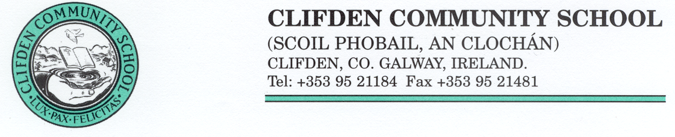
School Year 2021 – 2022
FOR ATTENTION OF ALL STUDENTS AND THEIR PARENTS/GUARDIANS
Acceptance of a place and attendance at the school implies acceptance by parents/guardians and pupils of the school’s policies and procedures.
All students and their parents/guardians are kindly asked to give an undertaking of their acceptance of the school’s Code of Behaviour and other policies as sanctioned by the Board of Management by completing the form set out below.
CLIFDEN COMMUNITY SCHOOL
PARENT-STUDENT STATEMENT OF RESPONSIBILITY (Required)
Student Name: _______________________________________ Date: __________________
I/We are happy to support the school by ensuring that my/our daughter/son behaves in accordance with the school’s Code of Behaviour. I/We agree to abide by the rules of behaviour, attendance, books, uniform and all other matters concerning the welfare of my son/daughter at Clifden Community School.
Parent(s)/Guardian(s) Signature(s) ___________________ __________________
Student's Signature _______________________ Date ___________________

Clifden Community School Photography/Digital Images Consent Form
Clifden CS takes pride in celebrating the achievements and participation of our students in the life of the school. Photographs/digital images of students engaging in school activities form part of school publications such as Newsletters and the School Website. You are requested to give your consent, or otherwise, to the publication of such photographs/digital images.
I / We, __________________________________ (PRINT NAME(S)) parent(s)/guardian(s)
of_______________________________________________(PRINT NAME)
grant permission/do not grant permission (delete as appropriate) to Clifden Community School, to take and use photographs / digital images of the above named student, engaging in school-related activities to appear in school publications.
Parent(s)/Guardian(s) Signature(s): _________________________ ________________________
Student’s Signature: _________________ Date: ________

